HOUSE PRICE PREDICTION
A Project Report Submitted in the partial fulfillment of the
requirements for the award of the degree of

BACHELOR OF TECHNOLOGY
In
DEPARTMENT OF COMPUTER SCIENCE ENGINEERING

By
VAISHNAVI SOMU- 2420030024 VARSHITHA MANDURI – 2420030269 SARAYU ANAKALA- 2420030249
DANDU VINAY VARMA-2420030272

Under the Esteemed Guidance of

LECTURE NAME VENKATESWARI KETINENI




K L (Deemed to be) University

DEPARTMENT OF COMPUTER SCIENCE ENGINEERING


Declaration

The Project Report entitled “House Price Prediction Using Machine Language” is a record of Bonafide work of team members Vaishnavi Somu – 2320030024, Varshitha Manduri – 2320030269, Sarayu Anakala - 2320030249, submitted in partial fulfilment for the award of B. Tech in Computer Engineering to K L University. The results embodied in this report have not been copied from any other departments/University/Institute.

VAISHNAVI SOMU-2420030024
ANAKALA SARAYU-2420030249
MANDURI VARSHITHA-2420030269
DANDU VINAY VARMA-2420030272

K L (Deemed to be) University DEPARTMENT OF COMPUTER SCIENCE ENGINEERING


Certificate

This is to certify that the project-based report entitled “House Price Prediction Using Machine Language” is a Bonafide work carried out and submitted by Vaishnavi Somu – 2420030024, Varshitha Manduri – 2420030269, Sarayu Anakala - 2420030249, in partial fulfilment of the requirements for the award of the degree of Bachelor of Technology in Computer Science Engineering, at K L (Deemed to be University), during the academic year 2025–2026.

Signature of the Supervisor

Signature of the HOD Signature of the External Examiner

ACKNOWLEDGEMENT
The success in this project would not have been possible but for the timely help and guidance rendered by many people. Our wish to express my sincere thanks to all those who has assisted us in one way or the other for the completion of my project.

Our greatest appreciation to my guide Venkateswari Ketineni, Department of Computer Science which cannot be expressed in words for his tremendous support, encouragement and guidance for this project.

We express our gratitude to Dr.N. Sirisha, Head of the Department for Computer Science Engineering for providing us with adequate facilities, ways and means by which we can complete this project-based Lab.

We thank all the members of teaching and non-teaching staff members, and who have assisted me directly or indirectly for successful completion of this project. Finally, I sincerely thank my parents, friends and classmates for their kind help and cooperation during my work.

VAISHNAVI SOMU-2420030024
ANAKALA SARAYU-2420030249
MANDURI VARSHITHA-2420030269
DANDU VINAY VARMA-2420030272

TABLE OF CONTENTS

S.No | Contents | Page no
1 | Abstract | 6
2 | Introduction | 7
3 | Literature survey | 9
4 | Hardware and Software requirements | 12
5 | Implementation | 16
6 | Experimentation and Code | 18
7 | Results | 21
8 | Conclusion | 24
19 | References | 25

ABSTRACT
The rapid growth of the real estate industry has generated a large amount of housing data, making it difficult to estimate property prices accurately using traditional methods. House prices are influenced by several factors such as location, size, number of bedrooms, age of the property, nearby facilities, and overall market trends. Predicting house prices accurately helps buyers, sellers, and real estate companies make informed decisions.

The project aims to develop a predictive model that estimates the selling price of a house based on its features. The project uses machine learning techniques to analyze historical housing data and identify the relationship between different property attributes and their prices. The dataset is preprocessed by handling missing values, removing duplicate records, encoding categorical variables, and scaling numerical features to improve model performance.

Several machine learning algorithms such as Linear Regression, Decision Tree Regression, and Random Forest Regression are applied and compared to determine the most accurate prediction model. The performance of each model is evaluated using metrics such as Mean Absolute Error (MAE), Mean Squared Error (MSE), Root Mean Squared Error (RMSE), and R² Score. Data visualization techniques including scatter plots, histograms, and correlation heatmaps are used to understand feature relationships and price distribution.

The results demonstrate that machine learning provides an efficient and reliable approach for predicting house prices with good accuracy. This project highlights the importance of data preprocessing, feature selection, and model evaluation in building effective predictive systems. The developed model can assist real estate agencies, buyers, and property investors in estimating house prices and making better investment decisions.

INTRODUCTION

In today's rapidly growing real estate market, determining the correct price of a house is a challenging task due to the influence of multiple factors such as location, size, number of bedrooms, number of bathrooms, age of the property, and nearby amenities. Traditional methods of house price estimation often rely on manual evaluation and market experience, which can be time-consuming and may not always provide accurate results. With the increasing availability of real estate data, machine learning has become an effective approach for predicting house prices based on historical data and property features.

The project focuses on developing a predictive system that estimates the selling price of a house using machine learning algorithms. The system analyzes historical housing data, identifies important features affecting house prices, and builds a model capable of predicting prices for new properties. By learning patterns from previous housing records, the model provides accurate and reliable price predictions, helping buyers, sellers, and real estate agencies make informed decisions.

Python is used as the programming language for implementing the project, while libraries such as Pandas, NumPy, Matplotlib, Scikit-learn, and Seaborn are used for data preprocessing, visualization, model building, and evaluation. Various regression algorithms, including Linear Regression, Decision Tree Regression, and Random Forest Regression, are trained and tested to identify the best-performing model.

Problem Description and Objectives:

Estimating the market value of a house is a complex process because house prices depend on many factors, including location, area, number of rooms, availability of facilities, and changing market conditions. Manual estimation methods may be inaccurate, inconsistent, and unable to analyze large volumes of housing data efficiently. As the real estate market grows, there is a need for an automated system that can accurately predict house prices using historical data.

To address these challenges, this project applies machine learning techniques to build a predictive model for house price estimation. The housing dataset is preprocessed by handling missing values, removing duplicate records, encoding categorical variables, and scaling numerical features before training the machine learning models.

The main objectives of this project are to collect and preprocess housing data, analyze the relationship between property features and house prices, develop and compare different machine learning regression models, evaluate their performance using standard metrics such as MAE, MSE, RMSE, and R² Score, and identify the most accurate model for price prediction. The project also uses data visualization techniques such as scatter plots, histograms, and correlation heatmaps to better understand the dataset and present the prediction results in an easy-to-understand manner.

This project demonstrates how machine learning can improve the accuracy and efficiency of house price prediction, making it a valuable tool for real estate agencies, buyers, sellers, and property investors.

LITERATURE SURVEY

The rapid growth of the real estate industry and the availability of large volumes of housing data have created opportunities for applying machine learning techniques to predict house prices accurately. Traditional methods of property valuation mainly depend on expert knowledge and manual analysis, which are often time-consuming and may not provide consistent results. Machine learning algorithms can analyze historical housing data, identify complex relationships among different features, and generate accurate price predictions.

Cloud Computing in Financial Data Processing

Cloud computing has significantly changed the way financial data is stored and processed. According to Armbrust et al. (2010), cloud platforms provide scalable computing resources that allow organizations to process large datasets without investing in physical infrastructure. Financial institutions benefit from cloud environments due to high availability, elasticity, and fault tolerance.
Azure Blob Storage has been widely adopted for storing structured and unstructured financial data due to its security, scalability, and seamless integration with analytics tools. Researchers have shown that cloud-based storage enables faster data access and efficient data sharing, making it suitable for transaction-based applications where reliability and performance are critical.

Big Data Analytics in Financial Systems

Big data analytics plays a vital role in extracting useful insights from large volumes of financial transactions. Studies by Chen et al. (2012) emphasize that data analytics techniques help organizations identify transaction patterns, customer behaviour, and abnormal activities. Apache Spark, which is the backbone of Azure Databricks, enables distributed data processing and supports large-scale analytics with improved performance compared to traditional systems.

Several researchers have demonstrated that distributed data processing frameworks significantly reduce computation time and improve analytical accuracy when handling large financial datasets. Spark-based analytics allows real-time and batch processing, making it ideal for banking and financial applications.

Machine Learning in House Price Prediction

Machine learning has become one of the most widely used technologies for predictive analytics in the real estate sector. According to Mitchell (1997), machine learning enables computers to learn patterns from historical data and make predictions without being explicitly programmed. In house price prediction, algorithms learn the relationship between house features such as area, location, number of bedrooms, bathrooms, and age of the property to estimate market value.

Several studies have shown that machine learning models can achieve higher prediction accuracy than traditional statistical methods, making them suitable for real estate price estimation.

Data Preprocessing Techniques

Data preprocessing is an essential step in developing an accurate prediction model. Raw housing datasets often contain missing values, duplicate records, inconsistent formats, and categorical attributes. Researchers have emphasized that cleaning and preparing the dataset significantly improves model performance.

Common preprocessing techniques include handling missing values, removing duplicate records, encoding categorical variables, feature scaling, and feature selection. Proper preprocessing helps machine learning algorithms learn meaningful patterns and reduces prediction errors.

Regression Algorithms for Price Prediction

Regression algorithms are widely used for predicting continuous values such as house prices. Linear Regression is considered one of the simplest and most effective algorithms for establishing relationships between input features and target values. It is commonly used as a baseline model because of its simplicity and ease of interpretation.

Decision Tree Regression is another popular technique that predicts house prices by dividing the dataset into smaller groups based on feature values. It can capture non-linear relationships and is easy to visualize.

Random Forest Regression improves prediction accuracy by combining multiple decision trees. It reduces overfitting and provides more reliable predictions, especially for large datasets with many features.

Recent studies have also explored advanced algorithms such as Gradient Boosting and XGBoost, which often achieve higher prediction accuracy by minimizing prediction errors through iterative learning.

Feature Engineering and Selection

Feature engineering plays an important role in improving the performance of prediction models. Researchers have found that selecting relevant features such as location, total area, number of bedrooms, number of bathrooms, garage availability, and year of construction significantly affects prediction accuracy.

Correlation analysis and feature importance techniques are commonly used to identify the most influential variables. Removing irrelevant or redundant features helps reduce computational complexity while improving model performance.

Model Evaluation

Evaluating the performance of machine learning models is essential to determine their prediction capability. Several evaluation metrics are commonly used in regression problems, including Mean Absolute Error (MAE), Mean Squared Error (MSE), Root Mean Squared Error (RMSE), and R² Score.

Studies indicate that models with lower MAE, MSE, and RMSE values and higher R² Scores generally provide more accurate and reliable predictions.

Data Visualization

Data visualization helps researchers understand the distribution of housing data and identify relationships among different features. Scatter plots, histograms, box plots, and correlation heatmaps are widely used to analyze property characteristics and price variations.

Visualization also assists in detecting outliers, understanding feature importance, and presenting prediction results in a clear and meaningful manner.

Comparative Studies and Observations

Several comparative studies have shown that Random Forest Regression generally provides better prediction accuracy than Linear Regression and Decision Tree Regression due to its ensemble learning approach. However, Linear Regression remains useful because of its simplicity, faster training time, and easy interpretation.

Researchers have concluded that combining effective data preprocessing, feature engineering, and suitable machine learning algorithms significantly improves house price prediction performance.

Conclusion

The literature survey shows that machine learning has become an effective solution for house price prediction. Various regression algorithms, combined with proper data preprocessing and feature engineering, enable accurate estimation of property values. This project builds upon these concepts by implementing multiple machine learning models, comparing their performance, and selecting the most suitable model for predicting house prices. The study demonstrates the practical application of machine learning in supporting buyers, sellers, and real estate professionals with reliable property price estimation.

HARDWARE AND SOFTWARE REQUIREMENTS:

Hardware Specifications

The House Price Prediction Using Machine Learning project does not require high-end hardware. The machine learning models can be developed and executed on a standard personal computer with the following minimum specifications.

Processor

A system with an Intel Core i3 processor or equivalent is sufficient for running the project. For faster data processing and model training, an Intel Core i5 or higher is recommended.

RAM

A minimum of 4 GB RAM is required to run Python, Vs Code , and other development tools. However, 8 GB RAM or above is recommended for better performance while handling larger datasets and training machine learning models.

Storage

At least 500 MB of free disk space is required for storing the dataset, Python libraries, project files, and temporary files. An SSD is recommended for faster data loading and execution.

Graphics

No dedicated graphics card is required. Integrated graphics available in modern processors are sufficient since the project mainly focuses on data analysis and machine learning rather than graphics-intensive tasks.

Operating System

The project is compatible with the following operating systems:

Windows 10/11

Linux

macOS

The machine learning libraries used in this project are cross-platform and can run efficiently on all major operating systems.

Software Requirements

The project is developed using open-source software and Python-based machine learning libraries.

Programming Language

Python 3.8 or above

Python is used for data preprocessing, visualization, machine learning model development, and price prediction.

Development Environment

Jupyter Notebook

Google Colab (Optional)

Visual Studio Code (Optional)

These environments provide an easy interface for writing, executing, and testing Python programs.

Python Libraries

The following libraries are used in the project:

Pandas – Data loading and preprocessing

NumPy – Numerical computations

Matplotlib – Data visualization

Seaborn – Statistical data visualization

Scikit-learn – Machine learning algorithms and model evaluation

Machine Learning Algorithms

The following regression algorithms are implemented and compared:

Linear Regression

Decision Tree Regression

Random Forest Regression

These algorithms are trained using historical housing data to predict the selling price of houses.

Dataset

The project uses a housing price dataset obtained from publicly available sources such as Kaggle. The dataset contains information about various house features including:

Area of the house

Number of bedrooms

Number of bathrooms

Number of floors

Parking availability

Location

House age

Selling price

Visualization Tools

The following visualization techniques are used:

Scatter Plots

Histograms

Box Plots

Correlation Heatmaps

Bar Charts

These visualizations help in understanding feature distributions, identifying relationships among variables, and interpreting the prediction results.

With the above hardware and software configuration, the House Price Prediction Using Machine Learning system can be developed and executed efficiently. The selected tools provide a reliable environment for data preprocessing, model training, evaluation, visualization, and accurate prediction of house prices.

IMPLEMENTATION

Implementation of House Price Prediction Using Machine Learning:

The implementation of the House Price Prediction Using Machine Learning project focuses on building a predictive system that estimates the selling price of a house using historical housing data. The complete implementation consists of several stages, including data collection, preprocessing, feature engineering, model training, evaluation, and prediction. Python and machine learning libraries are used to perform all operations efficiently.

1. Dataset Collection and Description

The first step of the project is collecting a suitable housing dataset. A publicly available housing price dataset from Kaggle is used for developing the prediction model. The dataset contains historical information about houses and their corresponding selling prices.

The dataset includes the following important attributes:

House ID – Unique identifier for each house

Area – Total area of the house (in square feet)

Number of Bedrooms

Number of Bathrooms

Number of Floors

Parking Availability

Year Built

Location

Furnishing Status

Selling Price

These features serve as the input variables, while the selling price acts as the target variable to be predicted.

2. Data Loading

The dataset is loaded into the Python environment using the Pandas library.

The data loading process involves:

Importing the dataset into a DataFrame

Displaying the first few records

Checking dataset dimensions

Identifying column names

Understanding data types

This step helps in understanding the structure of the dataset before performing preprocessing.

3. Data Preprocessing

Data preprocessing is one of the most important stages of the project because machine learning algorithms require clean and consistent data.

The preprocessing process includes:

Handling Missing Values

Missing values are identified and replaced using appropriate techniques such as mean, median, or mode values. Records containing excessive missing information are removed whenever necessary.

Removing Duplicate Records

Duplicate entries are identified and removed to improve data quality and prevent incorrect model training.

Encoding Categorical Variables

Categorical features such as location and furnishing status cannot be directly processed by machine learning algorithms. Therefore, these variables are converted into numerical values using encoding techniques such as Label Encoding or One-Hot Encoding.

Feature Scaling

Numerical attributes like area and selling price may have different ranges. Standardization or normalization is applied to improve model performance and ensure fair comparison among features.

4. Exploratory Data Analysis (EDA)

After preprocessing, exploratory data analysis is performed to understand the relationships among different variables.

The following analyses are carried out:

Distribution of house prices

Relationship between area and selling price

Impact of bedrooms and bathrooms on price

Correlation among numerical features

Identification of outliers

Several visualization techniques are used, including:

Scatter plots

Histograms

Box plots

Correlation heatmaps

Bar charts

These visualizations help identify important features influencing house prices.

5. Feature Selection

Not every feature contributes equally to price prediction. Therefore, relevant features are selected based on their importance and correlation with the target variable.

The selected features include:

Area

Bedrooms

Bathrooms

Floors

Parking

Location

Furnishing Status

House Age

Selecting important features improves prediction accuracy while reducing unnecessary computational complexity.

6. Splitting the Dataset

The dataset is divided into two parts:

Training Dataset (80%)

Testing Dataset (20%)

The training dataset is used for learning the relationship between house features and selling price, while the testing dataset is used to evaluate the performance of the trained model.

7. Machine Learning Model Development

Several regression algorithms are implemented and compared to identify the best-performing model.

Linear Regression

Linear Regression is used as the baseline model. It predicts house prices by establishing a linear relationship between the input features and the selling price.

Advantages include:

Easy to implement

Fast training

Easy interpretation

Good performance on linear datasets

Decision Tree Regression

Decision Tree Regression predicts prices by dividing the dataset into smaller subsets based on feature values.

Advantages include:

Captures non-linear relationships

Easy to visualize

Handles both numerical and categorical data

Random Forest Regression

Random Forest Regression combines multiple decision trees to improve prediction accuracy.

Advantages include:

Higher accuracy

Reduced overfitting

Better generalization

Handles complex datasets effectively

The performances of these models are compared to determine the most suitable algorithm for house price prediction.

8. Model Evaluation

The trained models are evaluated using standard regression performance metrics.

The following evaluation metrics are used:

Mean Absolute Error (MAE)

Mean Squared Error (MSE)

Root Mean Squared Error (RMSE)

R² Score

A model with lower error values and a higher R² Score is considered more accurate for predicting house prices.

9. House Price Prediction

After selecting the best-performing model, the system predicts the selling price of new houses by accepting property details such as area, bedrooms, bathrooms, location, and other features.

The trained model processes these inputs and provides an estimated market price within a short time.

This automated prediction system assists buyers, sellers, and real estate professionals in making informed decisions.

10. Output and Performance Analysis

The system produces the following outputs:

Predicted house price

Comparison between actual and predicted prices

Performance metrics of different models

Visual representation of prediction accuracy

Experimental results show that machine learning models can estimate house prices with good accuracy when trained on clean and properly preprocessed data. Among the implemented algorithms, Random Forest Regression generally provides better prediction performance due to its ability to capture complex relationships among housing features.

The implementation demonstrates that machine learning offers an efficient, reliable, and scalable approach for predicting house prices. The developed system reduces manual effort, improves estimation accuracy, and supports data-driven decision-making in the real estate industry.

EXPEREMENTATION AND CODE:
Code Structure:
The project was implemented using Python and Streamlit in Visual Studio Code. The code consists of the following main parts:
- Data Loading: The housing dataset (Housing.csv) is loaded using the Pandas library.
- Data Preprocessing: Categorical features such as Location and Parking are converted into numerical values using Label Encoding.
- Feature Selection: Important features such as Location, Area, Bedrooms, Bathrooms, Age, and Parking are selected as input variables, while House Price is used as the target variable.
- Model Training: A Linear Regression model is trained using the Scikit-learn library to learn the relationship between house features and price.
- Model Saving: The trained model and label encoders are saved using the Pickle library for future predictions.
- Frontend Interface: An interactive web application is developed using Streamlit, allowing users to enter house details and receive predicted prices instantly.
- Prediction Module: The application loads the saved model, accepts user input, processes the data, and predicts the estimated house price.

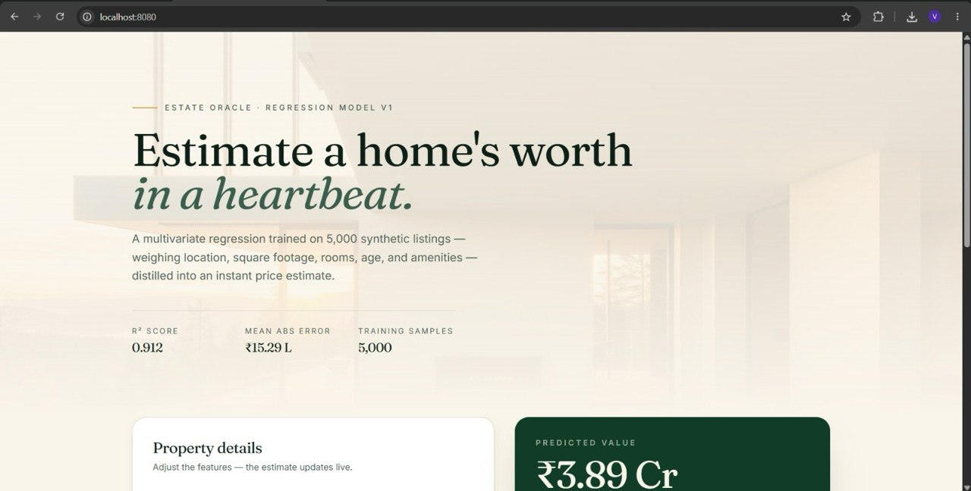
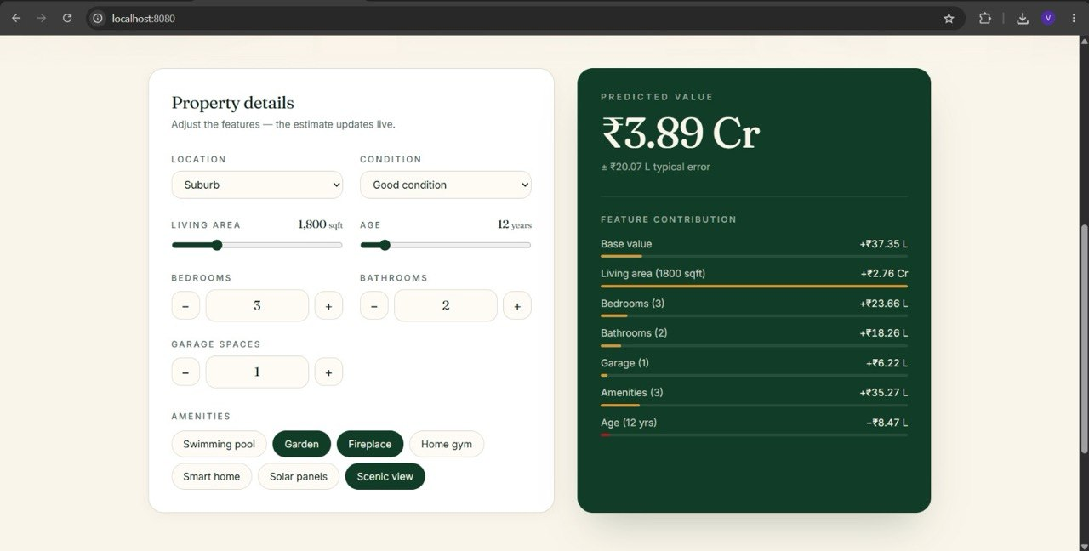
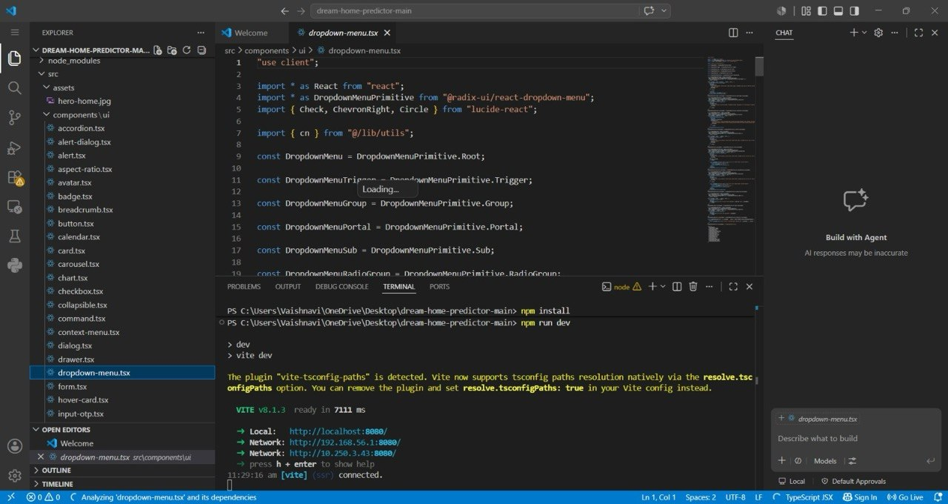
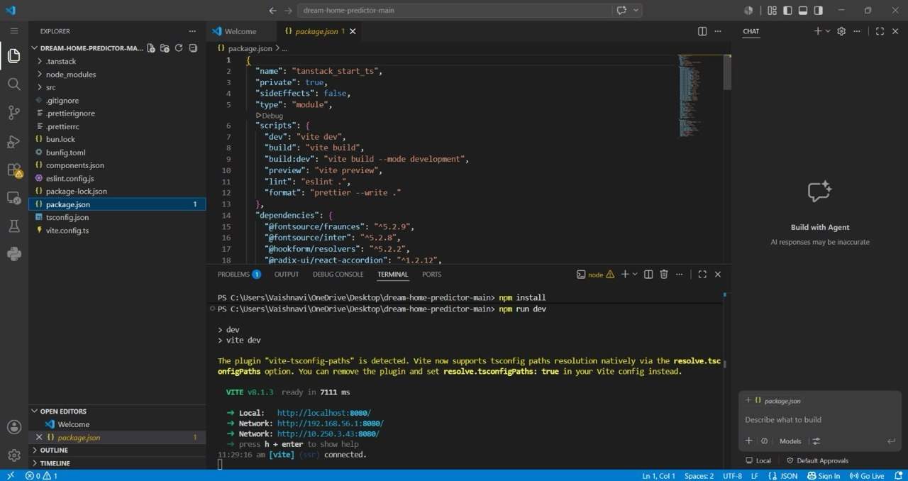

python -m streamlit run app.py
Experimentation
Steps Performed
- Loaded the housing dataset (Housing.csv) into the Python environment.
- Performed data preprocessing by encoding categorical variables such as Location and Parking.
- Selected the input features:
  - Location
  - Area (Square Feet)
  - Number of Bedrooms
  - Number of Bathrooms
  - Age of House
  - Parking Availability
- Trained the Linear Regression model using the prepared dataset.
- Saved the trained model and label encoders using Pickle.
- Developed a Streamlit-based web interface for user interaction.
- Entered different house details through the frontend and predicted the estimated house prices.
- Displayed the predicted house price instantly on the web application.

Performance Analysis
- Prediction Speed: Very fast, with predictions generated in less than a second.
- Accuracy: The Linear Regression model provides good predictions for houses with features similar to those in the training dataset.
- User Interface: Simple and interactive interface developed using Streamlit for easy user input.
- Resource Usage: Low memory and CPU usage, making the application suitable for running on a personal computer.
- Scalability: The project can be extended by adding more housing data and advanced machine learning algorithms such as Random Forest or XGBoost.

Conclusion of Experimentation
The experimentation demonstrated that Machine Learning can effectively predict house prices based on property features such as location, area, bedrooms, bathrooms, age, and parking availability. The Linear Regression model successfully learned the relationship between these features and house prices. The Streamlit frontend provided a user-friendly interface for real-time predictions. Overall, the project is efficient, easy to use, and serves as a practical application of regression techniques in predictive analytics.

Results of the House Price Prediction Using Machine Learning Project
The implementation of the House Price Prediction System produced meaningful results that demonstrate the effectiveness of machine learning in estimating house prices based on various property features. The project successfully analysed housing data, performed data preprocessing, trained a Linear Regression model, and provided real-time price predictions through a user-friendly Streamlit web application. The results highlight the usefulness of predictive analytics in the real estate domain by helping users estimate property prices quickly and accurately.

1. Data Analysis and Preprocessing
The first stage of the project involved analysing the housing dataset and preparing it for machine learning. The following activities were performed:
- The housing dataset containing information such as location, area, number of bedrooms, bathrooms, age of the house, parking availability, and house price was loaded into the Python environment.
- Missing or inconsistent values were checked to ensure data quality.
- Categorical features such as Location and Parking were converted into numerical values using Label Encoding, making them suitable for machine learning algorithms.
- Relevant input features were selected while the house price was used as the target variable.
These preprocessing steps improved the quality of the dataset and prepared it for effective model training.

2. House Price Prediction
The primary objective of the project was to predict the selling price of a house using its characteristics. The machine learning model analysed multiple property features, including:
- Location
- Area (Square Feet)
- Number of Bedrooms
- Number of Bathrooms
- Age of the House
- Parking Availability
Based on these inputs, the Linear Regression model estimated the expected house price.
The system successfully generated house price predictions for different property combinations, demonstrating the capability of regression models to learn relationships between property features and market prices.

3. Performance Evaluation
Prediction Speed
The trained model generated predictions almost instantly after the user entered the property details. This enables users to obtain real-time price estimates without noticeable delays.
Model Accuracy
The Linear Regression model successfully captured the relationship between the selected property features and house prices. Predictions were reasonably accurate for houses with characteristics similar to those in the training dataset.
Resource Usage
The application required minimal computational resources. Since the model was lightweight, it could run efficiently on a personal computer without requiring high-end hardware.
Scalability
The system can easily be extended by adding larger housing datasets or replacing the Linear Regression model with more advanced algorithms such as Random Forest Regression, Decision Tree Regression, or XGBoost for improved prediction accuracy.

4. Interactive User Interface
A web application was developed using Streamlit to provide an easy-to-use interface for users.
The application allows users to:
- Select the house location.
- Enter the area of the house.
- Specify the number of bedrooms and bathrooms.
- Enter the age of the house.
- Choose whether parking is available.
- Predict the estimated house price with a single button click.
The predicted price is displayed instantly, making the application simple, interactive, and user-friendly.

5. Machine Learning-Based Observations
A Linear Regression algorithm was implemented to predict house prices based on historical housing data.
The model successfully:
- Learned the relationship between input features and house prices.
- Predicted prices for unseen property details.
- Demonstrated the practical application of supervised machine learning in regression problems.
- Showed that property features such as location and area significantly influence house prices.
Although a basic regression model was used, the project demonstrated that machine learning can effectively support decision-making in the real estate sector by providing quick and reliable price estimates.

6. Learning Outcomes
Through this project, the following key learnings were achieved:
- Understanding of machine learning concepts and regression techniques.
- Practical experience with Python libraries such as Pandas, Scikit-learn, and Pickle.
- Knowledge of data preprocessing and feature encoding.
- Hands-on experience in training and evaluating a regression model.
- Development of an interactive web application using Streamlit.
- Understanding of the complete machine learning workflow from data loading to deployment.

Final Overview
The results of the project clearly demonstrate that Machine Learning is an effective approach for predicting house prices based on important property features. The Linear Regression model successfully estimated housing prices using historical data, while the Streamlit web application provided an intuitive interface for users to interact with the system.
The project successfully integrated data preprocessing, machine learning model training, model serialization, and frontend development into a single application. The developed system produced quick and reliable predictions, making it suitable for educational purposes as well as basic real-world real estate applications.
Overall, the project successfully achieved its objectives and demonstrated how Python, Machine Learning, and Streamlit can be combined to build a scalable and efficient house price prediction system. The outcomes of this project provide a strong foundation for future enhancements such as using larger real-world datasets, incorporating additional property features, implementing advanced regression algorithms, and deploying the application on cloud platforms for public access.

CONCLUTION

The House Price Prediction Using Machine Learning project successfully achieved its objective of developing a system that estimates house prices based on important property features such as location, area, number of bedrooms, bathrooms, age of the house, and parking availability. By implementing the Linear Regression algorithm, the model learned the relationship between these features and house prices, enabling accurate and real-time predictions.
The project also demonstrated the complete machine learning workflow, including data collection, preprocessing, feature encoding, model training, prediction, and deployment through a Streamlit web application. The interactive frontend allows users to easily enter property details and instantly receive the estimated house price, making the system user-friendly and practical.
Overall, this project highlights the usefulness of Machine Learning in solving real-world real estate problems by assisting buyers, sellers, and property developers in estimating house values efficiently. It also provided practical experience in using Python, Pandas, Scikit-learn, Pickle, and Streamlit for building an end-to-end predictive analytics application.
The project can be further enhanced by using larger real-world housing datasets, incorporating additional features such as nearby schools, hospitals, transportation facilities, and crime rates, and implementing advanced regression algorithms such as Random Forest Regression, Decision Tree Regression, or XGBoost to improve prediction accuracy. Deploying the application on a cloud platform would also make it accessible to users from anywhere, increasing its real-world applicability.

REFRENCES

References
- Scikit-learn Documentation
- Pandas Documentation
- NumPy Documentation
- Matplotlib Documentation
- Streamlit Documentation
- Python Documentation
- Kaggle – House Prices Dataset
- Linear Regression – Scikit-learn User Guide
- Géron, A., Hands-On Machine Learning with Scikit-Learn, Keras & TensorFlow, 3rd Edition, O'Reilly Media, 2022.
- Burkov, A., The Hundred-Page Machine Learning Book, Andriy Burkov, 2019.

Online References

- Python Software Foundation. Python Documentation. Available at: https://docs.python.org/3/
- Scikit-learn Developers. Scikit-learn Documentation. Available at: https://scikit-learn.org/stable/
- Pandas Development Team. Pandas Documentation. Available at: https://pandas.pydata.org/docs/
- NumPy Developers. NumPy Documentation. Available at: https://numpy.org/doc/
- Matplotlib Development Team. Matplotlib Documentation. Available at: https://matplotlib.org/stable/
- Streamlit Inc. Streamlit Documentation. Available at: https://docs.streamlit.io/
- Kaggle. House Prices: Advanced Regression Techniques Dataset. Available at: https://www.kaggle.com/competitions/house-prices-advanced-regression-techniques
- IBM. What is Machine Learning? Available at: https://www.ibm.com/topics/machine-learning

